Student exercise 1-3

***This exercise to be done by the student in class***

1. Write a program to input the name, surname and age of a person and print the following (input through Scanner class). Class name should be “inp”?

Output should be as follow:

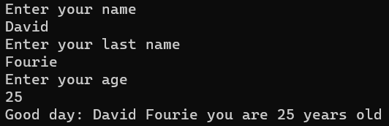

1. Write a program to check whether a given number is positive / negative or zero? Hard code the number value in the code to be tested. Also, use an if-else statement in your code. Class name should be “Ladder”.
2. Take the logic in question 2 into consideration and make the following changes:
   1. Delete the hard coded number value in your code and change the program so that the user is able to enter a number.
   2. Class name should be Ladder2

Output should be as follow:



Or



Or

